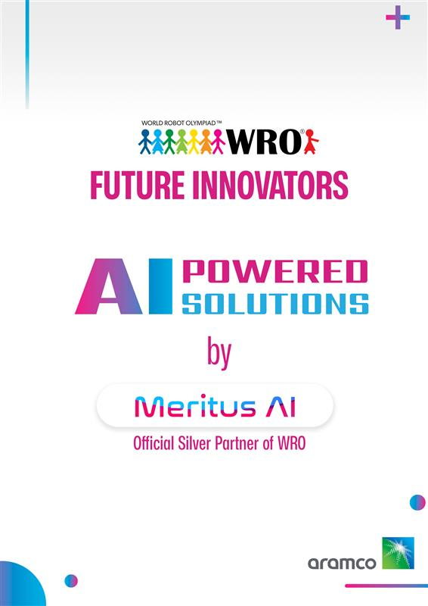

## **Table of Contents**

1. **Overview 3**
2. **Features 4**
3. **Why Choose This Kit? 6**
4. **Detailed Port Configuration (Ports 1 to 4) 7**
5. **Sensors and Modules List 9**
6. **Sensor and Module Ports 28**

**Overview:**

### **The Ultimate Microcontroller Kit for Future Innovators**

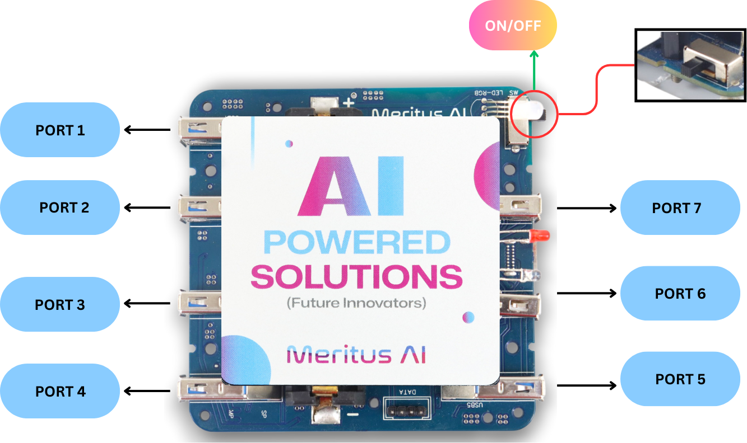

This microcontroller kit is engineered to revolutionize how you approach embedded systems and IoT projects. Acting as the central hub, it seamlessly integrates sensors, motors, AI cameras, and other modules to create a versatile, intuitive, and future-ready solution for innovators of all ages.

**Features:**

1. **Multi-functional Ports for Enhanced Connectivity:**
   * Seven GPIO Ports: Equipped with six General Purpose Input/Output (GPIO) ports for interfacing a wide array of sensors and peripheral devices, and one dedicated port for I2C communication. The I2C port ensures seamless compatibility with advanced modules such as AI cameras and environmental sensors.
2. **Next-Gen Power and Data Management:**
   * USB Type-C Port: A single Type-C port offers high-speed data transfer and efficient power delivery for charging. This modern standard ensures convenience and reliability for both data management and power needs.
3. **Integrated Motion and Control Modules:**
   * Includes motor driver modules to connect DC motors and servos, making it ideal for robotics, automation, and mobility applications.
   * Pre-integrated motor control ensures smooth operation, even for beginners.
4. **AI Vision Capabilities:**
   * Built-in support for AI cameras enables real-time image recognition, motion tracking, and machine learning tasks. This feature opens a wide range of possibilities for projects involving smart surveillance, automated systems, and interactive environments.
5. **Energy-Efficient Design:**
   * On/Off Switch: A user-friendly power switch helps conserve energy when the device is not in use, ensuring efficient operation.
6. **Expandable and Modular Design:**
   * Pre-included modules for vibration sensing, soil moisture analysis, and more ensure this kit is ready for projects in fields like agritech, climate monitoring, and health technologies.
7. **AI and Machine Learning Integration:**
   * Advanced AI-ready architecture supports machine learning models for predictive analytics and intelligent decision-making systems.

**Why Choose This Kit?**This microcontroller kit is not just a tool but a gateway to innovation. Whether you're working on robotics, smart cities, climate solutions, or AI-driven projects, this kit provides all the components and flexibility to turn your ideas into reality.

Ideal for:

* Students exploring STEM and robotics.
* Developers creating IoT or AI-integrated solutions.
* Innovators looking to prototype and experiment with real-world applications.

*Vision for Future Innovators:*  
Empower the next generation to dream, build, and solve real-world problems with this all-in-one kit. By integrating sensors, motors, AI cameras, and advanced connectivity options, this microcontroller kit embodies the essence of innovation and adaptability. It’s not just about building projects—it's about shaping the future.

### **Detailed Port Configuration (Port 1 to Port 4)**

**Purpose:**

Ports 1 to 4 are designed to support a variety of sensors and motors, offering flexibility and adaptability for diverse applications.

**Voltage Specifications:**

* The default VCC voltage for Ports 1 to 4 is 3.3V.
* For sensors requiring 5V constant power, a 3.3V to 5V DC boost converter is incorporated. This ensures stable and efficient power delivery without compromising the functionality of high-power sensors.

**Supported Devices:**

1. **Motors (Port 1 to 4):**
   * Supports DC motors.

### **2. Sensors (Port 1 to Port 4)**

The following sensors are compatible with Ports 1 to 4, utilizing the **3.3V to 5V DC boost converter** for those requiring 5V power:

* **Light Detector:** Measures light intensity for applications in smart lighting and energy conservation.
* **Motion Detector:** Detects movement for security systems and automation.
* **Vibration Sensor:** Monitors vibrations for structural health and equipment diagnostics.
* **Sound Sensor:** Detects sound levels for noise monitoring and smart audio systems.
* **Soil Moisture Sensor:** Measures soil moisture for agritech and irrigation systems.
* **Raindrop Sensor:** Detects rainfall for weather monitoring and water conservation.
* **Moisture Sensor:** Measures humidity and temperature for climate control and environmental monitoring.

***Key Advantages:***

* **Versatility:** Ports can interchangeably support sensors and motors, allowing dynamic configurations based on project needs.
* **Enhanced Power Management**: The inclusion of the boost converter makes it possible to integrate sensors requiring 5V power seamlessly.
* **Future-Ready Design:** Designed to accommodate a wide range of devices, including those with specific voltage requirements.

By ensuring both 3.3V and 5V compatibility, Ports 1 to 4 serve as a robust interface for developing innovative and versatile systems.

**Sensors and Modules list**

## **1. AI Camera Module**

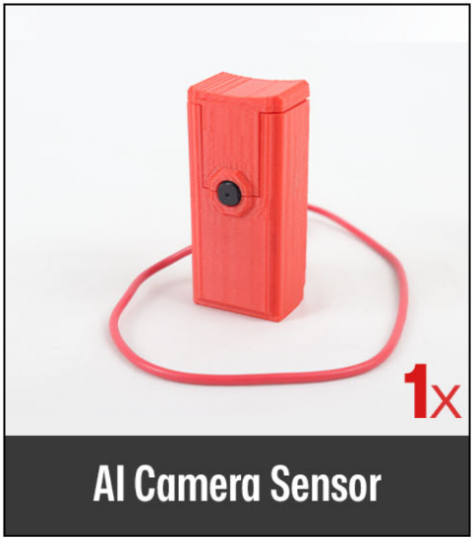

| **AI Camera Module** |
| --- |

### Port 6 is optimized for the camera module, enabling real-time AI-powered imaging solutions.

### **Specifications:**

* Microcontroller: ESP32 (dual-core, 240 MHz)
* Camera: OV2640, 2MP, max resolution UXGA (1600x1200)
* Connectivity: Wi-Fi, Bluetooth 4.2
* Storage: 4 MB Flash, MicroSD slot (up to 4 GB)
* Interfaces: GPIO, UART, SPI, I2C, PWM
* Special Features: AI support (face detection/recognition)

### **Future Usefulness:**

* Security Systems: Face detection for smart access control or automated surveillance.
* Autonomous Vehicles: Object detection and path recognition for navigation.
* Healthcare: Patient activity monitoring in hospitals using video analytics.
* Agriculture: Identify pests or diseases in crops using image recognition.
* Wildlife Monitoring: Non-intrusive surveillance of wildlife for ecological studies.

## **2. DC Motors + Encoder**

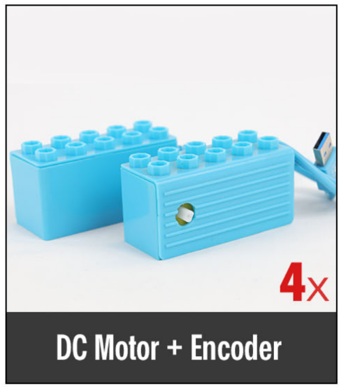

| **DC Motors + Encoder** |
| --- |

**Port 1 to Port 4:** Dedicated for motor connections.

* + Supports **DC motors**.
  + Ideal for robotics, automation, and motion control applications.

This configuration ensures seamless motor integration, offering precise control for innovative projects.

### **Specifications:**

* Encoders: Provides feedback on position, speed, and direction
* Control: PWM for speed regulation
* Ports: Motors connect to Ports 1–4 (avoid sensor conflict)

### **Future Usefulness:**

* Robotics: Precision movement in autonomous robots and drones.
* Smart Farming: Automate machines like plows and harvesters.
* Education: Build robots for learning motion control and feedback systems.

## 

## 

## 

## 

## **3. Servo Motor**

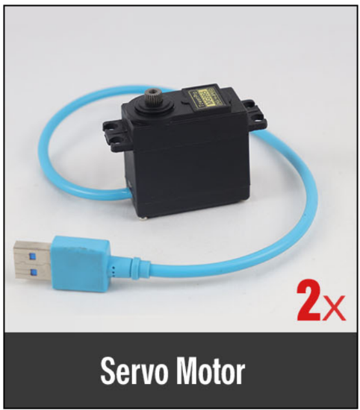

| **Servo Motors** |
| --- |

Ports: Signal pins connect to Port 5

### **Specifications:**

* Control: PWM signal for angle control

### **Future Usefulness:**

* Robotics: Control robotic arms, grippers, and pan-tilt systems.
* Medical Devices: Prosthetics and precision surgical tools.
* Automation: Automate doors, camera movement, or valves.
* Smart Gadgets: Develop interactive toys and smart home systems.

## 

## **4. Moisture Sensor**

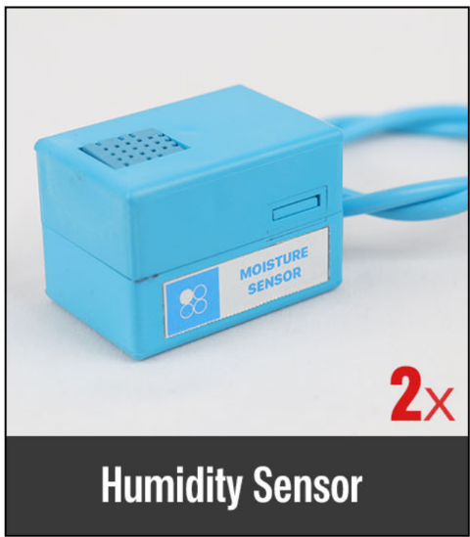

| **Moisture Sensor** |
| --- |

Port 4: Dedicated for the humidity and temperature sensor.

### **Specifications:**

* Output: Serial data
* Temperature Range: 0°C to 50°C
* Humidity Range: 20% to 90%
* Resolution: Temperature and Humidity both are 16-bit
* Accuracy: ±1°C and ±1%

### **Future Usefulness:**

* Smart Homes: Optimize air conditioning and ventilation systems.
* Agriculture: Monitor greenhouse humidity for better crop growth.
* Health Tech: Control humidity for asthma and respiratory devices.
* Industrial Use: Preserve moisture-sensitive goods like textiles.

## **5. IR Sensor**

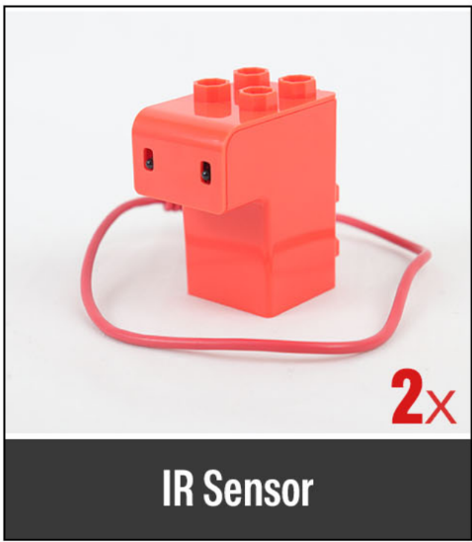

| **IR Sensor** |
| --- |

Port 6: Dedicated for the IR sensor

### **Specifications:**

* Detection range: 2cm – 30cm (Adjustable using potentiometer)
* Active output level: The output is “0” (Low) when an obstacle is detected

### **Future Usefulness:**

* Obstacle Detection: Enable autonomous robots to avoid collisions.
* Line Following Robots: Use IR sensors for path navigation.
* Safety Systems: Implement automated doors and alarms.
* Smart Parking: Detects vehicles in parking lots for availability.

## **6. Ultrasonic Sensor + IR Hub**

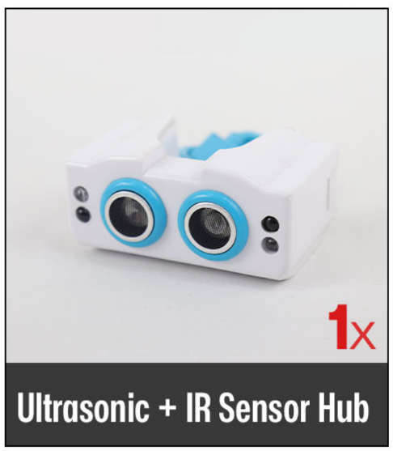

| **Ultrasonic Sensor + IR Hub** |
| --- |

Port 5: Dedicated for the Ultrasonic + IR Sensor Hub

### **Specifications:**

* Ultrasonic: HC-SR04, Range: 2 cm to 400 cm
* IR: Digital signal for close-range detection
* Communication: GPIO multiplexing

### **Future Usefulness:**

* Robotics: Combine ultrasonic and IR for precise obstacle detection.
* Security Systems: Detects motion and presence in smart alarm systems.
* Smart Cars: Implement parking assistance systems.
* Smart Cities: Traffic monitoring and waste bin level detection.

## **7. Motion Detector**

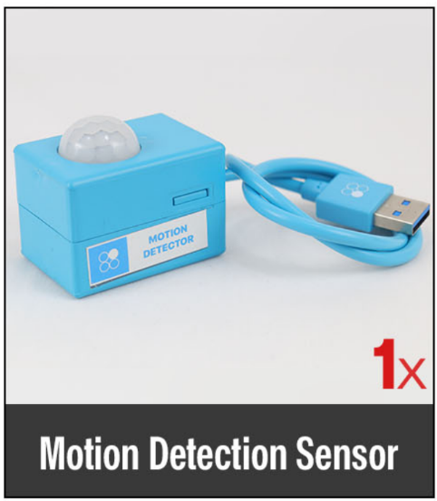

| **Motion Detector** |
| --- |

Port 1: Dedicated for the motion detection sensor

### **Specifications:**

* Current Drain: <60uA
* Detection Angle: <140°
* Detection Distance: 3 to 7m (can be adjusted)
* Blockade time: 2.5s (Default)
* Work temperature: -20-+80°C

### **Future Usefulness:**

* Smart Security: Detects intruders in automated security systems.
* Energy Saving: Control lights based on motion detection.
* Healthcare: Monitor patient activity for fall detection.
* Home Automation: Develop smart room systems that activate devices with motion.

## **8. Color Sensor**

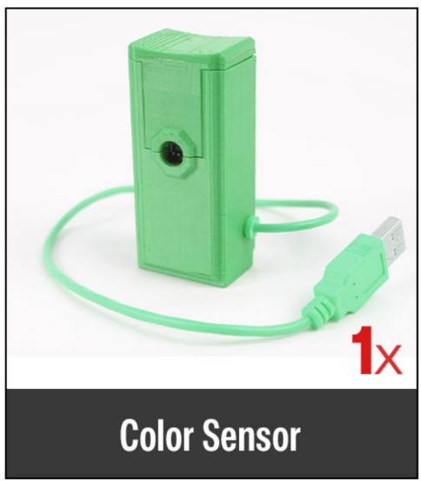

| **Color Sensor** |
| --- |

Port 7: Dedicated for the Color sensor

### **Specifications:**

* The TCS3472 device provides digital return values for red, green, blue (RGB) and bright light sensing
* Color management is more accurate.
* The high sensitivity and Wide dynamic range.
* IR shading filters make the TCS3472 ideal.

### **Future Usefulness:**

* Quality Control: Detects color changes in manufacturing processes.
* Smart Agriculture: Monitor crop health based on leaf color.
* Robotics: Build robots capable of color sorting and detection.
* Smart Devices: Create interactive systems responding to colors.

## **9. Light Detector**

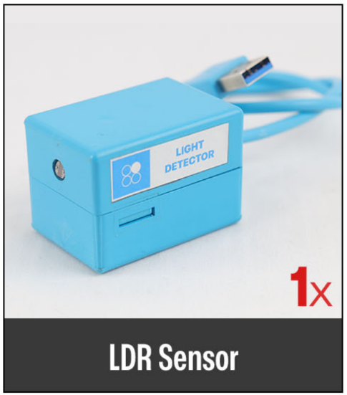

| **Light Detector** |
| --- |

Port 1: Dedicated for the LDR sensor

### **Specifications:**

* Comparator chip: LM393
* Output type: Analog
* Sensitivity: Adjustable
* Indicator LED: output and power LED Indicator

### **Future Usefulness:**

* Smart Lighting: Control street lights based on ambient light.
* Solar Tracking: Adjust solar panels for optimal energy collection.
* Environment Monitoring: Measure natural light levels in greenhouses.
* Photography: Develop auto-exposure systems for cameras.

## **10. Vibration Sensor**

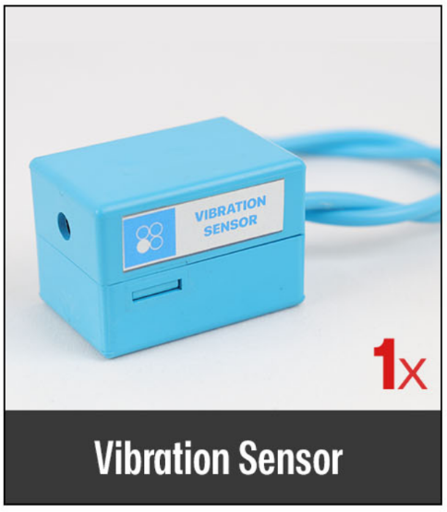

| **Vibration Sensor** |
| --- |

Port 3: Dedicated for the Vibration sensor

### **Specifications:**

### Operating Current: 15mA

* Using SW-420 normally closed type vibration sensor
* LEDs indicating output and power

### **Future Usefulness:**

* Earthquake Detection: Build early warning systems.
* Machinery Monitoring: Identify faults through abnormal vibrations.
* Wearable Tech: Detects movements for fitness and health tracking.

## **11. Sound Sensor**

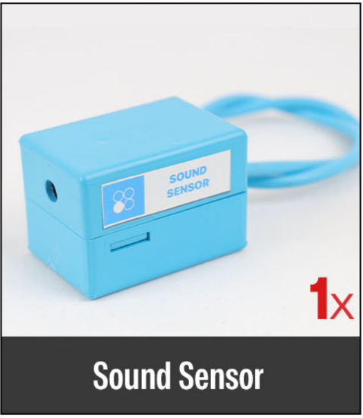

| **Sound Sensor** |
| --- |

Port 3: Dedicated for the Sound Sensor

### **Specifications:**

* Output: single channel signal
* IC chip: LM393

### **Future Usefulness:**

* Smart Systems: Create clap-activated switches for lights or fans.
* Surveillance: Detects unusual noises in security systems.
* Health Monitoring: Develop noise-level alerts for hearing safety.

## **12. RGB LED Output**

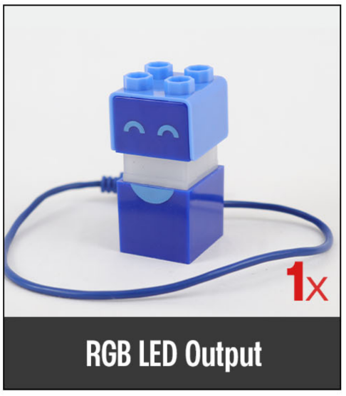

| **RGB LED Output** |
| --- |

Port 6: Dedicated for the RGB LED output

### **Specifications:**

* **Data**: Controlled via GPIO pin
* Programmable for dynamic colors and effects.

**Applications**:

* **Smart Lighting**: Mood-based and adaptive lighting.
* **Status Indicators**: Color-coded system states.

## **13. Rain Drop Sensor**

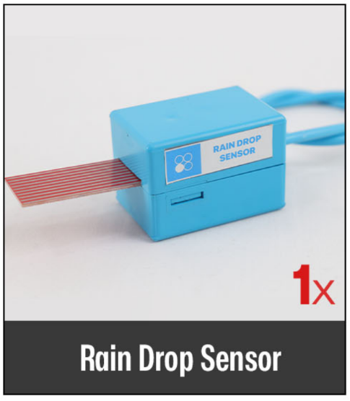

| **Rain Drop Sensor** |
| --- |

Port 3: Dedicated for the Rain Drop sensor

### **Specifications:**

* Operating current: Less than 20ma
* Sensor type: Analog
* Detection area: 40mmx16mm
* Operating temperature: 10-30℃

### 

### 

### **Future Usefulness:**

* **Smart Irrigation:** Automate water usage in farms based on rainfall.
* **Weather Stations:** Measure real-time rain levels.
* **Flood Alerts:** Detect excessive rainfall to prevent damage.
* **Research:** Study precipitation patterns and environmental impact.
* **Urban Planning:** Optimize drainage and water management systems

## **14. Soil Moisture Sensor**

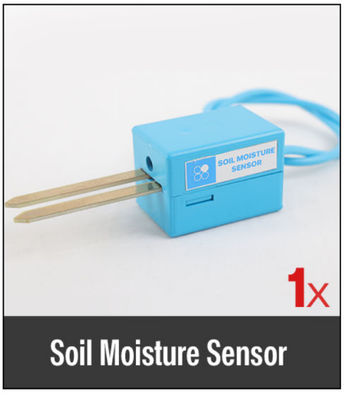

| **Soil Moisture Sensor** |
| --- |

Port 2: Dedicated for the Soil Moisture sensor

### 

### **Specifications:**

* Output voltage signal: 0~4.2v
* Current: 35mA
* Dimensions(mm):40.0(L)x20.0(W)x20.0(H)

### **Future Usefulness:**

* **Smart Agriculture:** Automate irrigation and improve crop yield.
* **Precision Farming:** Optimize planting and fertilization.
* **Landscape Management:** Maintain gardens and greenhouses.
* **Urban Farming:** Automate watering for vertical gardens.
* **Environmental Conservation:** Prevent over-irrigation and save water.
* **Education:** Teach soil science and moisture monitoring.
* **IoT Integration:** Enable remote soil condition monitoring.

## 

## 

## 

## 

## 

## 

## **15. Temperature Probe**

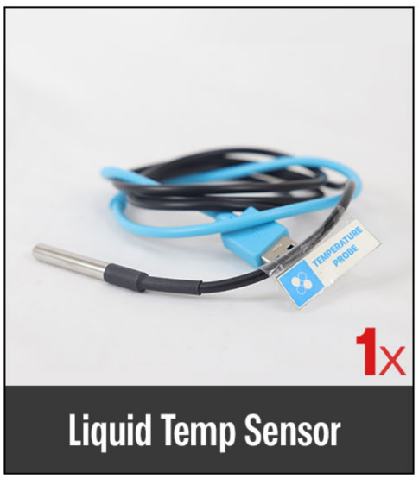

| **Temperature Probe** |
| --- |

Port 5: Dedicated for the Liquid Temp sensor

### **Specifications:**

* **Temp. Comp. Range:** 0°C to 50°C
* **Temperature Sensor:** Platinum Resistance Temperature Detector (RTD)
* **Operating Temperature:** -20°C to 80°C
* **Temp. Sensor Accuracy:** ± 0.05ºC

### **Future Usefulness:**

* Food Industry: Monitor temperature in storage.

## 

## **16. Touch Sensor**

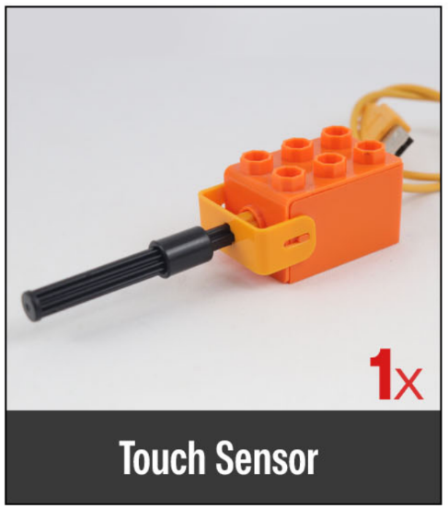

| **Touch Sensor** |
| --- |

Port 6: Dedicated for the Touch Sensor

### **Future Usefulness:**

* Interactive Systems: Build touch-based interfaces for IoT devices.

## 

## 

## 

## **17. Health Sensor**

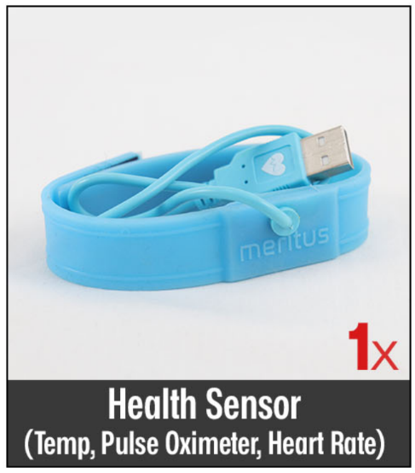

| **Health Sensor** |
| --- |

Port 7: Dedicated for the Health Sensor

### **Specifications:**

* Temperature Range: -40˚C to +85˚C
* Temperature Accuracy: ±1˚C

### **Future Usefulness:**

* Wearable Health Tech: Track heart rate and oxygen levels.

**Sensor and Module Ports**



